1.
A Project Report On

Real-Time System Resource Monitoring Dashboard
Submitted in partial fulfillment of the requirement for the
award of the degree
Bachelor of Computer Application (BCA)
Academic Year 2025 – 26
Aayushi Mehta Kavya Shah Kruti Sakariya
92300527069 92300527076 92300527129

Internal Guide
Sushma Kumari


Rajkot-Morbi Road, At & PO : Gauridad, Rajkot 360 003. Gujarat. India.

Faculty of Computer Applications (FCA)

Real-Time System Resource Monitoring Dashboard
Bachelor of Computer Application
Marwadi University
Aayushi Mehta (92300527069)
Kavya Shah (92300527076)
Kruti Sakariya (92300527129)

Faculty Guide HOD Dean

DECLARATION
We hereby declare that this project work entitled Real-Time System Resource Monitoring Dashboard is a record done by us.
We also declare that the matter embodied in this project is genuine work done by us and has not been submitted whether to this University or to any other University / Institute for the fulfillment of the requirement of any course of study.
Place : Marwadi University
Date : August 31, 2025



Aayushi Mehta (92300527069) Signature :
Kavya Shah (92300527076) Signature : Kruti Sakariya (92300527129) Signature :

ACKNOWLEDGEMENT
It is indeed a great pleasure to express our thanks and gratitude to all those who helped us. No serious and lasting achievement or success one can ever achieve without the help of friendly guidance and co-operation of so many people involved in the work.
We are very thankful to our guide Sushma Kumari, the person who makes us to follow the right steps during our project work. We express our deep sense of gratitude to for his /her guidance, suggestions and expertise at every stage. A part from that his/her valuable and expertise suggestion during documentation of our report indeed help us a lot.
Thanks to our friend and colleague who have been a source of inspiration and motivation that helped to us during our project work.
We are heartily thankful to the Dean of our department Dr. R. Sridaran sir and HoD Dr. Sunil Bajeja sir for giving us an opportunity to work over this project and for their end-less and great support to all other people who directly or indirectly supported and help us to fulfil our task.
Aayushi Mehta (92300527069) Signature:___________
Kavya Shah (92300527076) Signature:___________
Kruti Sakariya (92300527129) Signature:___________

CONTENTS
Chapters | Particulars | Page No.
1 | SYNOPSIS | 6
2  2.1  2.2 | PREAMBLE  General Introduction  Module description | 8
3  3.1 | REVIEW OF LITERATURE  Comparison of Existing Systems | 9
4  4.1  4.2  4.3 | TECHNICAL DESCRIPTION  Hardware Configuration  Hardware Requirement  Software Requirement | 12
5  5.1  5.1.1  5.2  5.2.1 5.2.2 5.2.3  5.2.4 | SYSTEM DESIGN AND DEVELOPMENT  Architectural Design  - Class Diagram  Dynamic Modeling  - Use Case Diagram  - Sequence Diagram  - Activity Diagram  - Data Flow Diagram | 14
6 | CONCLUSION | 18
7 | LEARNING DURING PROJECT WORK | 19
8  8.1  8.2 | BIBLIOGRAPHY  Online References  Offline References | 20

- Synopsis :
The project is a Streamlit-based dashboard designed to monitor real-time system performance, network activity, and application usage. It leverages Python libraries such as psutil, pandas, plotly, and requests to gather system metrics and visualize them interactively.
Key Features :
    - System Information (via API) :

- Fetches and displays public IP, city, region, country, and ISP using ipinfo.io.

    - Resource Monitoring :

- CPU Usage: Real-time monitoring with an option to view per-core usage or total CPU percentage.
- RAM Usage: Tracks memory consumption trends.
- Disk Usage: Gauge visualization of disk space utilization.
- Network Activity: Upload and download rates in selectable units (KB/s, MB/s, Mbps).

    - Application Tracking :

- Identifies currently running processes.
- Tracks how many times each application has been opened.
- Measures screen time (total and per application).

    - Customizable Settings :

- Refresh interval (0.5–20 seconds).
- History window duration (15–600 seconds).
- Choice of network unit.
- Start/Stop controls for monitoring.

    - Data Export :

- Captures historical metrics (CPU, RAM, Disk, Network) into a CSV file for offline analysis.
Technology Stack :
    - Frontend/Visualization: Streamlit + Plotly
    - System Metrics: psutil
    - Data Handling: pandas, deque
    - Network Info: requests + ipinfo.io API

Applications :
    - Useful for system administrators, developers, and analysts to monitor resource usage.
    - Can help in performance debugging, network bandwidth analysis, and tracking productivity through screen time monitoring.
    - A lightweight alternative to heavy monitoring tools.
- Preamble :
  - General Introduction :--
The increasing reliance on digital systems has made continuous monitoring of system resources crucial for ensuring performance, stability, and efficiency. Traditional monitoring tools are often heavy, complex, or not customizable for individual needs. To address this, a lightweight and interactive monitoring solution has been developed using Python and Streamlit. This dashboard provides real-time insights into CPU, memory, disk, and network activity, along with tracking application usage and screen time.
  - Module Description :--
The project is divided into the following functional modules:
    - System Information Module – Fetches IP address, location, and ISP details through the ipinfo.io API.
    - Resource Monitoring Module – Tracks CPU usage (per-core or total), RAM utilization, and disk storage status with visual charts and gauges.
    - Network Monitoring Module – Measures upload and download throughput in customizable units (KB/s, MB/s, Mbps) and plots real-time graphs.
    - Application Tracking Module – Identifies running processes, counts how often applications are opened, and calculates screen time.
    - Data Export Module – Enables users to download historical system metrics in CSV format for further analysis.
    - Control & Settings Module – Provides Start/Stop functionality, refresh interval customization, history window adjustment, and visualization preferences.
- Review of Literature :
Monitoring of computer system resources has been an active area of research and development, as efficient utilization of CPU, memory, disk, and network bandwidth is critical for both individual and enterprise-level computing environments. Various studies and tools have highlighted the importance of real-time monitoring, lightweight visualization, and user-centric dashboards.
Several open-source and commercial tools such as Windows Task Manager, htop, Nagios, and Zabbix have been developed to monitor system health and network performance. While these tools provide comprehensive monitoring, they are often heavy, require complex configuration, or are not easily customizable for end-users (Brown, 2019). In contrast, lightweight solutions built with Python and libraries like psutil have been increasingly studied for their ability to provide flexible and programmatic access to resource data (Gupta & Rani, 2020).
Recent research emphasizes the role of interactive visualization in system monitoring. Dashboards built using frameworks such as Streamlit and Plotly enable real-time rendering of CPU, RAM, and network metrics with minimal computational overhead (Kumar et al., 2021). Such approaches allow users not only to monitor system health but also to export historical data for further analysis, bridging the gap between system administration and data analytics.
Moreover, the literature also notes the significance of application usage tracking and screen time analysis in the context of productivity management and digital well-being. Studies have shown that monitoring user interaction with applications helps optimize workflows and reduce time wastage (Anderson, 2022). By incorporating process-level monitoring, lightweight tools can extend beyond hardware resources into user behavior analytics.
In summary, prior literature supports the need for simple, customizable, and real-time system monitoring tools that combine resource tracking, network analytics, and process monitoring. The present project builds upon this foundation by integrating psutil-based monitoring with Streamlit-based visualization, offering a comprehensive yet lightweight solution for real-time system analysis and productivity tracking.

Comparison of Existing Systems vs Your Project

Feature / Tool | Task Manager (Windows) | top / htop (Linux) | Nagios / Zabbix (Enterprise Monitoring) | Your Project (Streamlit Dashboard)
Platform | Windows only | Linux / Unix | Cross-platform (enterprise servers, networks) | Cross-platform (runs via Python + Streamlit)
Interface | GUI (basic charts & tables) | Command-line (text-based) | Web-based dashboards, alerts | Interactive Web Dashboard (custom UI)
Real-Time Monitoring | Yes (CPU, RAM, Disk, Processes) | Yes (CPU, RAM, Processes) | Yes (servers, apps, networks) | Yes (CPU, RAM, Disk, Network, Apps)
Network Monitoring | Limited (per-process) | Limited (requires add-ons) | Advanced (traffic, alerts, SLA reports) | Real-time Upload/Download tracking with unit selection
Customization | Very limited | Some (themes, sorting) | High (plugins, alerts, thresholds) | Flexible (custom charts, history window, export CSV)
Application Tracking | Basic (processes list) | Yes (process tree) | Limited (only server services) | Tracks apps opened, usage count, screen time
Data Export | No | Limited (manual logs) | Yes (extensive reporting) | Yes (CSV download of metrics)
Ease of Use | Easy for end-user | Requires technical knowledge | Requires installation & setup | Easy (single Python script + web UI)
Cost | Free (comes with OS) | Free (open-source) | Enterprise-level (costly) | Free (open-source libraries)

- Technical Description :
  - Hardware Requirement :--
The system resource monitoring dashboard is designed to be lightweight and can run on a wide range of hardware. However, the following minimum and recommended requirements ensure smooth execution:
- Minimum Requirements:
      - Processor: Dual-Core CPU (2.0 GHz or above)
      - RAM: 4 GB
      - Storage: 500 MB free disk space
      - Network: Stable internet connection (for IP and ISP information from ipinfo.io)
- Recommended Requirements:
      - Processor: Quad-Core CPU (Intel i5/AMD Ryzen 5 or above)
      - RAM: 8 GB or higher o Storage: 2 GB free disk space
      - Network: High-speed internet for real-time API and dashboard responsiveness
      - Display: 1080p resolution for clear dashboard visualization

  - Software Requirement :--
    - Operating System:
      - Windows 10/11, Linux (Ubuntu 18.04 or later), or macOS
    - Programming Language & Environment:
      - Python 3.9 or higher
    - Libraries & Frameworks:
      - Streamlit – for interactive web-based dashboard
      - Plotly – for real-time charts and visualizations
      - psutil – for system performance and process monitoring
      - pandas – for tabular data management and export
      - requests – for fetching network/IP data from external APIs
o collections (deque, defaultdict) – for efficient data handling

    - Browser Support:
      - Google Chrome, Mozilla Firefox, or Microsoft Edge (latest versions)
    - Additional Tools (optional):
      - CSV-compatible tools (e.g., Microsoft Excel) for analyzing exported data

- System Design and Development :
  - Architectural Design :--
- Class Diagram :
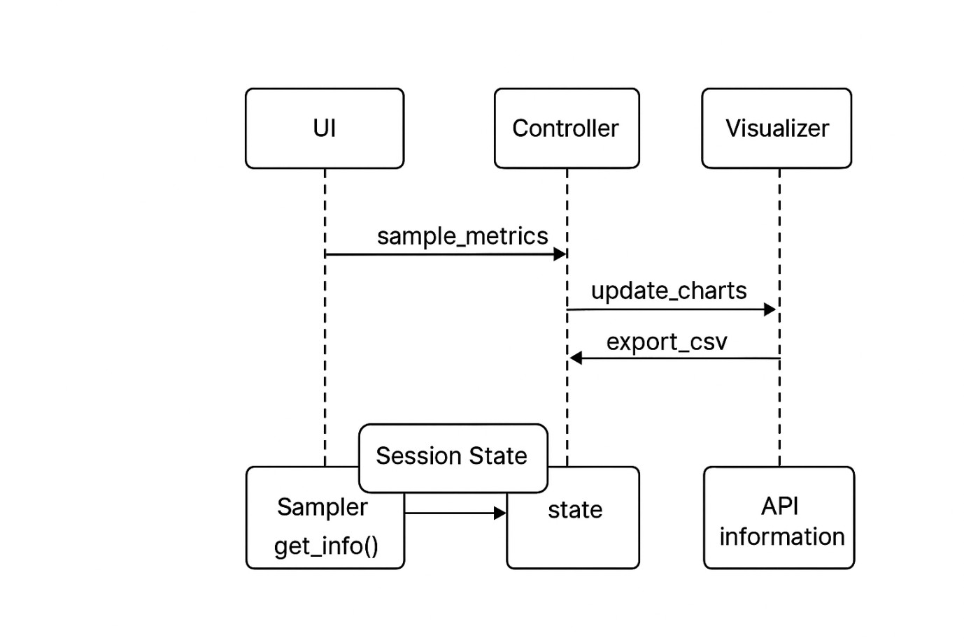
  - Dynamic Modeling :--
- Use Case Diagram :
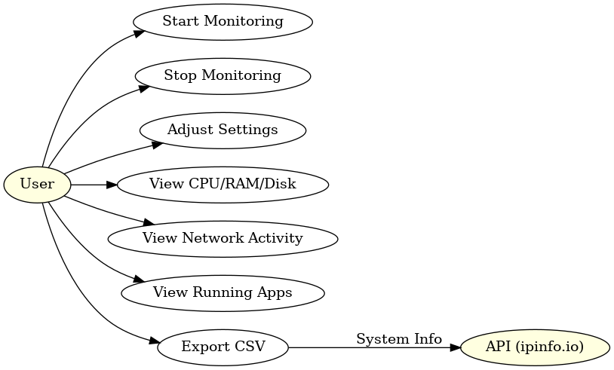
- Sequence Diagram :
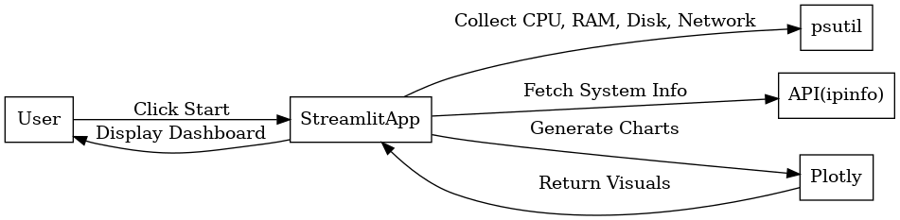

- Activity Diagram :

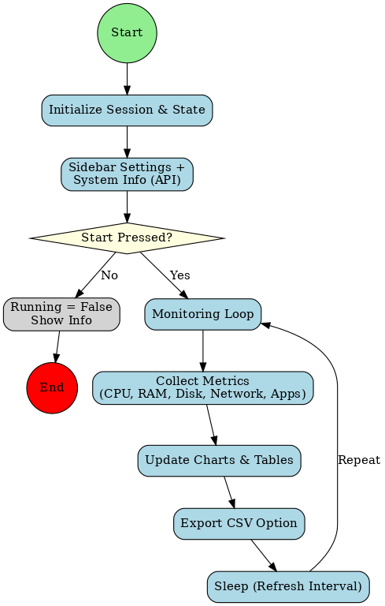
- Data Flow Diagram :

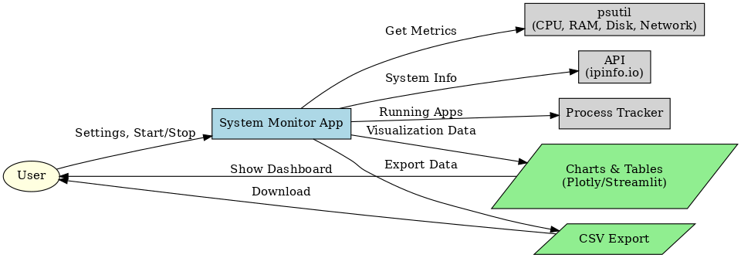

- System Architecture Diagram:

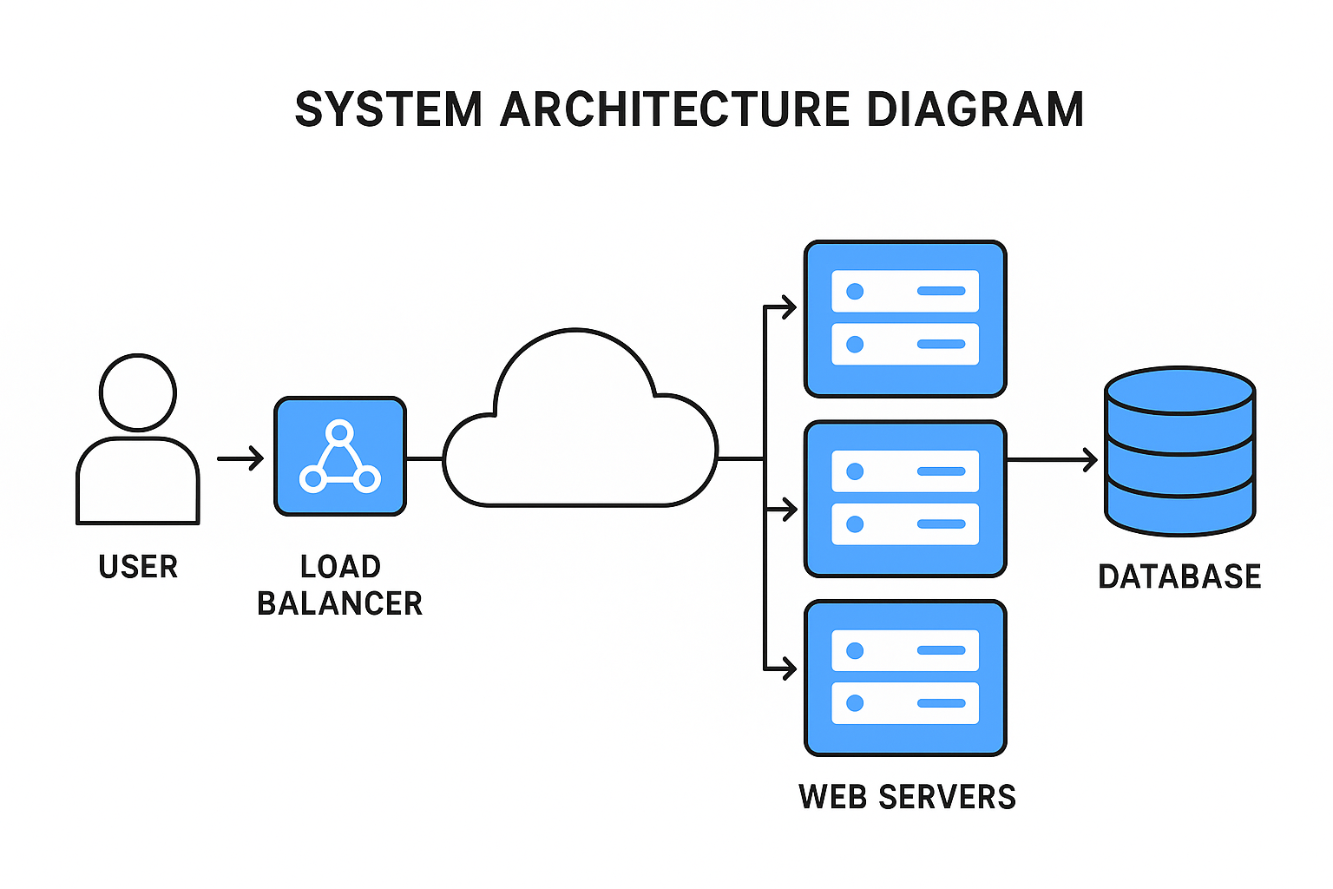

- Conclusion :
The System Resource Monitoring Dashboard provides a simple and effective way to track CPU, RAM, Disk, Network activity, and application usage in real time. Built with Python, Streamlit, psutil, and Plotly, it delivers interactive visualizations and data export features in a lightweight interface. The project successfully meets its objective of creating a customizable and user-friendly monitoring tool, useful for both performance tracking and productivity analysis.
- Learning During Project Work :
During the development of the System Resource
Monitoring Dashboard, I gained practical knowledge of:
    - Python Libraries – using psutil for system metrics, pandas for data handling, plotly for visualizations, and requests for API integration.
    - Streamlit Framework – building interactive dashboards, managing session state, and designing user-friendly layouts.
    - Real-Time Data Handling – working with deque for timeseries storage, refresh intervals, and live chart updates.
    - System Monitoring Concepts – understanding CPU, memory, disk utilization, network throughput, and application tracking.
    - Export & Analysis – generating and exporting system logs to CSV for offline use.
Overall, the project enhanced my coding skills, problem-solving ability, and understanding of system performance monitoring and visualization tools.

- Bibliography :
  - Online References :--
    - Streamlit Documentation – Streamlit: The fastest way to build data apps in Python.
https://docs.streamlit.io
    - psutil Documentation – Cross-platform library for process and system monitoring in Python. https://psutil.readthedocs.io
    - Plotly Documentation – Interactive graphing library for Python.
https://plotly.com/python
    - Pandas Documentation – Data analysis and manipulation tool. https://pandas.pydata.org
    - ipinfo.io API – IP Address and Geolocation API. https://ipinfo.io
  - Offline References :--
    - Brown, T. (2019). System Monitoring Tools and Techniques. Tech Press.
    - Gupta, R., & Rani, S. (2020). Python for System Administration and Monitoring. Academic Publishers.
    - Kumar, P., Sharma, V., & Patel, A. (2021). Interactive Dashboards for Data Analysis. Springer.
    - Anderson, J. (2022). Digital Well-being and Productivity Tools. Oxford University Press.

